EYFS / KS1 – Long Term Plan for 2019-2020
 | Term 1 |  |  | Term 2 |  |  | Term 3
 | Half term 1 |  |  | Half term 1 |  |  | Half term 1
Literacy | Linking stories to own experiences |  | Core text:  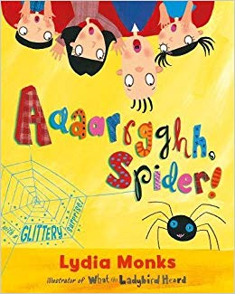  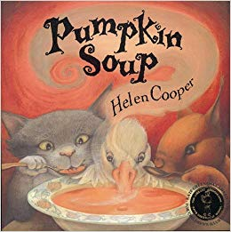 | Report | Stories with reoccurring Literary Language | Core text:  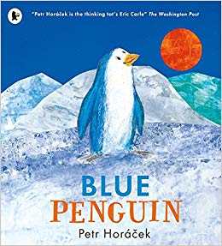 | Instructions | Traditional Tales | Core text:  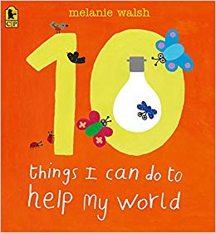  Linking Texts:  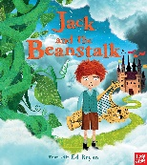
 | Information Text | Labels, Captions and Lists. |  | Vocabulary Building – Free Verse
Science | Human Bodies |  |  | Animals |  |  | Plants (Recycling)
Wider curriculum | Geography:  Local Area | Art: Self Portraits |  | Geography:  Contrasting Localities  Human and Physical Features. | Art: Printing, colours |  | Geography:  Skills and Communication | DT: Food Technology
 | Music:  Hey You! | MFL:  Greetings |  | Music:  In the Groove | MFL:  Animals |  | Music:  Your Imagination | MFL:  Fruits
 | ICT:  Create, Manage and Manipulate – Skills. Digital Content |  |  | ICT:  Digital Research |  |  | ICT:  Sound
Visit | Village Walk/ Local Area Visits. |  |  | Flamingo Land |  |  | Scampston Walled Garden
 | Half term 2 |  |  | Half term 2 |  |  | Half term 2
Literacy | Stories with predictable phrasing |  | Core text:  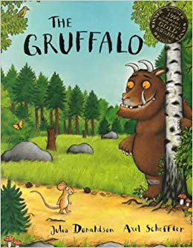  Linking Texts:  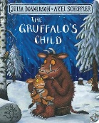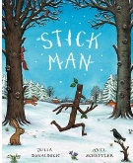 | Explanations | Shape Poetry | Core text:  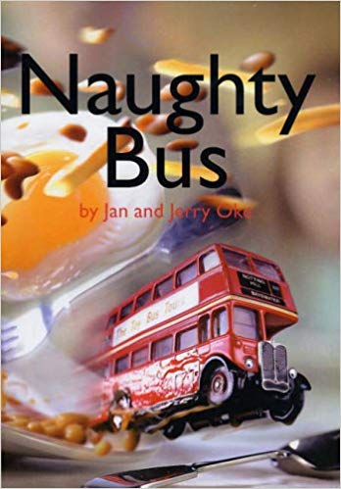 | Report | Stories with recurring language | Core text:  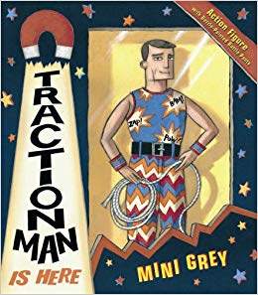
 | Recount | Rhyming Couplets |  | Acrostic Poems |  |  | Take one poet – Poetry appreciation
Science | Materials |  |  | Investigations Focus (Forces)  Revisit and Review  Scientists – Historical and Modern Day |  |  | Living Things and Habitats
Wider curriculum | History:  Homes – Then and Now | DT:  Building houses & Structures |  | History:  Events/people and changes.  History of Transport | DT:  Vehicles and Mechanisms |  | History:  History of Toys – Now and Then | Art:  Space Art
 | Music: Rhythm in the way we walk | MFL: Colours |  | Music:  In the Groove | MFL:  Numbers |  | Music:  Reflect, Rewind and Replay | MFL:  Songs
 | ICT:  Create, Manage and Manipulate – Knowledge and Understanding.  Data Handling. |  |  | ICT:  Online Safety |  |  | ICT:  Simulations and Modelling
Visit | Dalby Forest – Gruffalo Trail / Autumn Walk  Wednesday 6/11/2019 |  |  | Bus Station/Train Station  York Railway Museum |  |  | Planetarium –Visit to school for a federation day.

