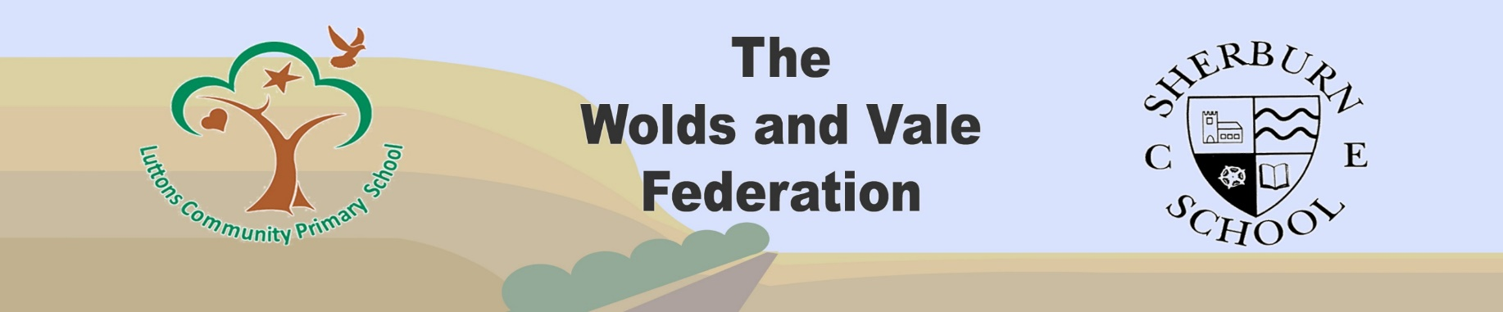

Luttons Science Long Term Overview
Class 1 (KS1)
Year A (1) | Year B (2) | Year C (1) | Year D (2)
Autumn Term
CLPE Text:  10 things I can do to help my world  Year 1: Animals  (Other animals) | CLPE Text:  Naughty Bus  Year 2: Health  (How we grow and stay healthy) | CLPE Text:  Orion and the Dark  Year 1: Animals  (Humans) | CLPE Text:  The Gruffalo  Year 2: Environment/Animals  (living things and their habitats/animal survival and growth)
CLPE Text:  The Emperor’s Egg  Year 1: Animals  (Other animals) | CLPE Text:  Traction Man  Year 2: Material Properties  (Uses of Everyday Materials) | CLPE Text:  The Jolly Postman  Year 1: Material Properties  (Everyday Materials) | CLPE Text:  Moth  Year 2: Environment/Animals  (living things and their habitats/animal survival and growth)
Spring Term
CLPE Text:  Leaf  Year 1: Plants  (Common names and basic structure) | CLPE Text:  Rapunzel  Year 2: Environment/Animals  (living things and their habitats/animal survival and growth) | CLPE Text:  The Secret Sky Garden  Year 1: Animals  (Other animals) | CLPE Text:  Poems to Perform  Year 2: Health  (How we grow and stay healthy)
CLPE Text:  Beegu  Year 1: Material Properties  (Everyday Materials) | CLPE Text:  The Last Wolf  Year 2: Environment/Animals  (living things and their habitats/animal survival and growth) | CLPE Text:  The Story Tree  Year 1: Animals  (Other animals) | CLPE Text:  If all the world were…  Year 2: Plants  (Plant growth)
Summer Term
CLPE Text:  Aaarrgghh Spider!  Year 1: Animals  (Humans) | CLPE Text:  The Secret of Black Rock  Year 2: Plants  (Plant growth) | CLPE Text:  Zeraffa Giraffa  Year 1: Plants  (Common names and basic structure) | CLPE Text:  Egg Box Dragon  Year 2: Material Properties  (Uses of Everyday Materials)
CLPE Text:  Is There a Dog in This Book?  Scientists and Inventors  (Revisit and Review) | CLPE Text:  Here Comes Frankie  Scientists and Inventors  (Revisit and Review) | CLPE Text:  Grendel  A cautionary tale about chocolate  Scientists and Inventors  (Revisit and Review) | CLPE Text:  Here We Are  Scientists and Inventors  (Revisit and Review)
Year 1: Astronomy and Light (Seasonal Changes)
Sessions to be included across each whole school year. Each half term to focus on seasonal change from Autumn/Winter and Spring/Summer
Class 2 (KS2)
Year A (3) | Year B (4) | Year C (1) | Year D (2)
Autumn Term
CLPE Text:  One Plastic Bag  Year 5: Material Properties  (Testing material properties) | CLPE Text:  Clockwork  Year 4: Animals  (Teeth, eating and digestion) | CLPE Text:  Arthur and the Golden Rope  Year 4: Material Properties and Changes  (states of matter) | CLPE Text:  Tales of Wisdom and Wonder  Year 4: Electricity  (Electricity)
CLPE Text:  The Ice Bear  Year 4: Environment  (Living things and their habitats) | CLPE Text:  Ug  Year 3: Material Properties  (Rocks) | CLPE Text:  Queen of Darkness  Year 3: Health  (health and nutrition) | CLPE Text:  The Pebble in my Pocket  Year 6: Environment  (Evolution and inheritance)
Spring Term
CLPE Text:  The Wild robot  Year 6: Electricity  (Electricity) | CLPE Text:  Treason  Year 6: Astronomy and Light  (How light travels) | CLPE Text:  Rose Blanche  Year 3: Animals  (Skeletons and Movement) | CLPE Text:  MacBeth  Year 5: Forces  (effects of movement)
CLPE Text:  Moon Man  Year 5: Astronomy and Light  (Earth and space) | CLPE Text:  Treason  Year 5: Environment  (Observing life cycles) | CLPE Text:  One Thousand and One Arabian Nights  Year 6: Environment  (Classification) | CLPE Text:  The Matchbox Diary  Year 5: Animals  (Human life cycles)
Summer Term
CLPE Text:  Goodnight Mister Tom  Year 6: Animals  (Exercise, health and the circulatory system) | CLPE Text:  Town is by the Sea  Year 3: Forces  (non-contact forces) | CLPE Text:  Odysseus  Year 5: Material Changes  (reversible and irreversible changes) | CLPE Text:  The Viewer  Year 3: Light and Astronomy  (light, reflections and shadows)
CLPE Text:  Is There a Dog in This Book?  Year 6: Animals  (Exercise, health and the circulatory system) | CLPE Text:  Here Comes Frankie  Year 4: Sound  (Sound) | CLPE Text:  Grendel  A cautionary tale about chocolate/  Charlie and the Chocolate Factory  Year 5: Material Changes  (reversible and irreversible changes) | CLPE Text:  Here We Are  Year 3: Plants  (functions of parts of plants)
Scientists and Inventors
Sessions to be included across each whole school year. Each half term to focus on a specific scientist/inventor relevant to the taught unit.

